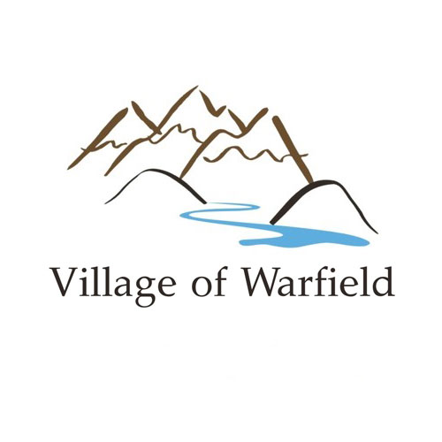**INTER-MUNICIPAL ACCESSIBILITY**

**ADVISORY COMMITTEE**

**MEMBERS NEEDED-NOW RECRUITING**

Do you want to get involved and help the Villages of Warfield, Montrose and Fruitvale become more accessible? The Villages are partnering to create the Warfield, Montrose and Fruitvale Inter-municipal Accessibility Advisory Committee.

The Villages are recruiting individuals living in Warfield, Fruitvale and Montrose who personally experienced accessibility challenges and/or who have the lived-experience as a person with a disability to serve on the Committee. This Committee should represent the diversity of people living throughout BC, including but not limited to the broad range of under-served and equity-seeking groups such as, but not limited to Indigenous Peoples, new Canadians, persons living in poverty, people of diverse ethnic or cultural origin, seniors, women, and youth.

The Inter-municipal Accessibility Advisory Committee (the Committee) is a committee established under Part 3, Section 9 of the *Accessible British Columbia Act* and the *Accessible British Columbia Regulation 105/22.* To meet the requirements under this legislation, the Inter-municipal Accessibility Advisory Committee is created with the purpose to assist Warfield, Montrose and Fruitvale in identifying, preventing and removing barriers experienced by persons with disabilities.

Committee members provide advice and make recommendations to the Village Councils on a range of initiatives intended to make the three municipalities more physically accessible. A committee member will serve for up to a three-year term with a mid-term review.

Committee members will work together to:

* Participate in group discussions to provide an understanding of accessibility issues within the community.
* Identify barriers to individuals living in and/or interacting with, the Villages of Warfield, Montrose and Fruitvale.
* Make recommendations to the Village Councils on how to reduce existing and prevent barriers in the future.
* Evaluate and provide solutions to address accessibility challenges.
* Assist in the prioritization of concerns raised.
* Contribute to the development of a Warfield, Montrose and Fruitvale Inter-municipal Accessibility Plan.
* Provide feedback to Councils on matters referred to the Committee by the Councils.
* Attend two (2) committee meetings per year. Meetings will be arranged to be held both virtually and in-person.

Committee members will be reimbursed for any out-of-pocket expenses to attend the meetings and will be given an honorarium of a $50.00 grocery store gift card for each meeting attended.

The composition of the committee aspires to reflect the diversity of the three municipalities. Applicants should live within the Villages of Warfield, Montrose and Fruitvale.

**How to Apply**

Applicants are encouraged to highlight their experience surrounding accessibility in their application forms.

Application forms can be found at: <https://warfield.ca/>, <https://www.montrose.ca/>, and <https://fruitvale.ca/> or by request at: [corporateofficer@warfield.ca](mailto:corporateofficer@warfield.ca).

Paper copies of the application forms can also be picked up in-person at:

**Village of Warfield:**

555 Schofield Highway, Trail, BC V1R 2G7 250-368-8202

**Village of Montrose:**

Box 510, 565-11th Avenue, Montrose, BC V0G 1P0 250-367-7234

**Village of Fruitvale:**

Box 370, 1947 Beaver Street, Fruitvale, BC V0G 1L0 250-367-7551

**Submission of Completed Application Forms:**

Completed application forms should be submitted to your respective municipality, either in-person or via Canada Post at the addresses noted above.

**Deadline for submitting applications:** Friday Dec. 1st.

You may also submit your completed application form and any questions you may have to:

Village of Warfield Corporate Officer at: [corporateofficer@warfield.ca](mailto:corporateofficer@warfield.ca)